A Privacy Protected Deep Learning Approach to Classify Gallbladder from Cholecystography image under Federated Learning Environment

Abstract
Recently artificial intelligence (AI) has shown significant advancements and promising prospects in the medical image field. Machine learning (ML) models have become frequently used for detection and classification. Machine learning (ML) models need huge amounts of data, though this data often tends to face limited access to the organization due to privacy concerns. To solve the problem this paper uses federated learning (FL), which allows models to be trained on different datasets across different locations without the need to centralize sensitive data. This research explores three different deep learning (DL) models- VGG16, ResNet50 and Vision Transformer (ViT) to detect different categories of gallbladder diseases and the most effective model is selected to use for the global model inside the FL framework. The dataset contains nine different categories of gallbladder disease images, which are split into 70% for training, 20% for validation and 10% for testing. Preprocessed the data through normalize and resize. This framework allows the model to be trained by several separate data sources without the data being moved to a central server. Client trains a local model with their data and then these local models are combined using Federated Averaging process which creates a global model that reproduces all client data patterns without accessing it openly. The result of the global model shows that there is no significant difference between the FL method and the best-performing DL method as the results of the FL method are the same as the best-performing DL model in gallbladder classification.
Introduction
Gallbladder disease is a very common disorder that has two conditions non-cancerous (begin) and cancerous (malignant) among them the common are non-cancerous (begin) and gallbladder cancer (malignant). There are also other types of begin conditions like polyps, adenomyomatosis, and acute cholecystitis, which can cause various symptoms like abdominal pain, jaundice, and fever, though some patients may have no symptoms at all. Since this diagnosis is challenging because benign conditions can sometimes appear similar to cancer on imaging tests, accurate identification is crucial for proper treatment and management[1]. Ultrasonic imaging is mostly used to diagnose gallbladder because of its accessibility and diagnostic accuracy. If the diagnosis is not managed early it can lead to financial burden. In the USA it is the most costly digestive disease.[2] Thus an automatic detection system and classification in improving diagnostic accuracy and efficiency can be helpful for proper treatment and management. Artificial intelligence (AI) has shown significant achievement in the medical field.[3]
The implementation of AI into healthcare diagnostics allows faster and more accurate disease detection and classification. Also it reduces the workload of doctors and improves patient outcomes. Machine learning (ML) and deep learning (DL) models have proved notable performance in detecting patterns in complex medical images. However, the success of these models relies heavily on access to large, high-quality datasets, which are often constrained by privacy regulations and organizational policies. Thus hospitals may not want to provide data due to much privacy concern. Federated learning (FL) shows a promising method that allows training the model in different locations without needing to share raw data.[4]

In this study, we use the FL framework for Gallbladder detection from ultrasonic images where the client data stays hidden during the process. The dataset is divided into three parts: train, test and validation and the ratio is 7:2:1. Among the three DL models VGG16, ResNet50, and vision transformer (Vit) the best-performed one is selected for the FL framework. Ultimately compared the accuracy rate for both DL models and FL framework. In our proposed method the contributions are that we proposed a privacy-protected model by implementing the FL framework which allows decentralized training without sharing sensitive medical data.

Literature Review
DL has become a base in the medical image field. It has shown significant results in medical image analysis, offering transformative solutions for tasks such as disease classification, segmentation, and object detection across diverse medical fields.[5] Using a neural network [6] to build a model for the classification of gallbladder polyps. Another study [7] various ML models like K-Nearest Neighbors (KNN), Multilayer Perceptron (MLP), Support Vector Machine (SVM), Decision Tree, Random Forest, AdaBoost, Gradient Boosting, Naïve Bayes, and Logistic Regression to predict gallstones. They tuned model parameters and selected the best-fitted model according to accuracy, precision, recall, and AUC scores, which show how well each model predicted the presence of gallstones. MobileNet used ultrasonic images to detect gallbladder disease. Four pre-trained DNN models (VGG16, InceptionV3, ResNet152, MobileNet) were fine-tuned with additional layers to classify images into nine disease types and used Adam optimizer over 15 iterations to improve accuracy.[8] A CNN with Multiscale Second-Order Pooling (MS-SoP) was used to detect gallbladder cancer, where preprocess data (ultrasonic image) with augmentation and trained the model with Gaussian blurring and fine-tuned a pre-trained network.[9] Another Study on the prediction of gallbladder cancer using ML.[10] They used the Boruta algorithm to select important features from data and then used eight ML algorithms like `avNNet`, `glmnet`, and `mda` and evaluated the models based on ROC results. Sana et al proposed an automated gallbladder cancer detection artificial gorilla troops optimizer with transfer learning on ultrasound images. To achieve this the ultrasonic images were preprocessed using median filtering to remove noise, and then utilized Inception module, a deep learning network, optimized the perimeter of the model using the Artificial Gorilla Troops Optimizer (AGTO).[11] In 2021 a method was proposed where three CNN models were created ResNet, Inception v3 and DenseNet for feature extraction and evaluated performance by using metrics like accuracy, sensitivity, specificity, and AUC.[12] The GBCNet model was created for detecting gallbladder cancer from USG Images. Combines CNNs and Faster R-CNN for efficient gallbladder localization in ultrasound images.[13] There are many studies that use ML and DL in image classification in the medical field and have shown potential results. Deep learning models need large amounts of data for the best results but due to privacy concerns parties can not share their data with a centralized server to train the model. To address that FL method is a good approach that enable parties to jointly learn a machine-learning model without exchanging their local data. [14] According to [15] this study used the FL framework for breast cancer classification which allows multiple institutions to collaborate by sharing model parameters instead of patient data. Their experiments demonstrate that the federated learning approach achieves results comparable to centralized learning, proving its feasibility and efficiency.

Description of the Dataset
We have utilized cholecystography images from[16]. The dataset contains a total of 10,692 cholecystography images which have nine separate classes. In Figure 1 visual description is given of our dataset. The nine classes contain Gallstones, Abdomen and retroperitoneum, Cholecystitis, Membranous and gangrenous cholecystitis, Perforation, Polyps and cholesterol crystals, Adenomyomatosis, Carcinoma, Various causes of gallbladder wall thickening. We split this dataset in train, validation and testing with a 7:2:1 ratio and used ImageDataGenerator.
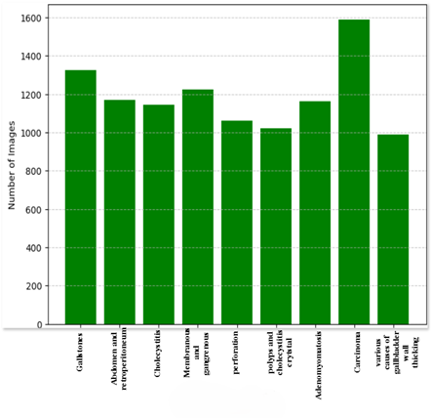
Figure 1. Class distribution of the cholecystography dataset.
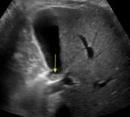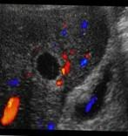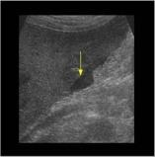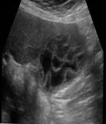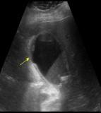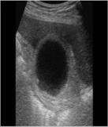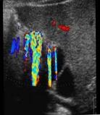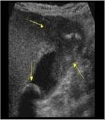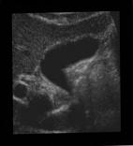
- (b) (c) (d) (e) (f) (g) (h) (i)
Figure 2. Sample data of cholecystography dataset (a) Gallstones (b) Abdomen and retroperitoneum (c) cholecystitis (d) Membranous and gangrenous cholecystitis (e) Perforation (f) Polyps and cholesterol crystals (g) Adenomyomatosis (h) Carcinoma (i) Various causes of gallbladder wall thickening.

Deep learning architectures
In our proposed method we apply a two-stage approach. First, we evaluate three different DL modes VGG16, ResNet50 and Vision transformer (Vit). To implement this we use TensorFlow and Keras libraries. TenserFlow seamlessly integrates probabilistic modeling with modern deep learning techniques[17] and Keras for its simplicity, flexibility, and robust capabilities in deploying and training deep learning models.[18] Each model was individually trained with the cholecystography image dataset to evaluate the results. With this evaluation, the best-performing model is selected for integration into a federated learning framework, enabling decentralized training.
VGG16: With five blocks of convolutional layer the model is designed and each block is monitored by a max-pooling layer. Working together these layers gradually simplify the image while extracting the features which are effective for the image classification tasks.
The implementation was done as follows:
- Removed the original fully connected layers.
- Utilize the Flatten layer to flatten the output from the last convolutional block.
- To classify the image into nine categories a dense layer with nine neurons was added.
- Trained the model with Adam Optimizer and the learning rate was 0.0001which reduced the error by adjusting the weights.
ReNet50: This is a deep convolutional neural network with 50 layers. This uses skip connections to address the problem of vanishing gradient, these connections help the model maintain better gradient flow and make training more effective.
The implementation was done as follows:
- Like VGG16, removed the original fully connected layers.
- Utilize the Flatten layer to flatten the output from the last convolutional block.
- To classify the image into nine categories a dense layer with nine neurons was added.
- Trained the model with Adam Optimizer and the learning rate was 0.0001which reduced the error by adjusting the weights.
Vision transformer (Vit): Unlike other models, Vit processes images in a unique way. This model uses a Self-attention mechanism instead of convolutional layers.
The implementation was done as follows:
- First, resize the image in 64×64 pixels and use the Patches layer to split the images into smaller patches in 3×3 pixels.
- Utilized PatchEncoder layer so that each patch is encoded into a lower-dimensional space and also keeps track of the relationship between patches.
- There are 8 transformer layers where the encoded patches pass through. Each layer has
- Multi-head attention focuses on different parts of the image at once.
- Layer normalization to stabilize training.
- A feedforward neural network (MLP) to process the information further
- Skip connection to help preserve gradients and make training more stable.
- After the transformer layers, use the Flatten layer to convert the output into a one-dimensional vector. Where the Dropout layer has a 50% rate to reduce overfitting.
- (MLP head) a dense layer for feature representation and a softmax layer for classification into different categories.
- Used AdamW optimizer with a learning rate of 0.0001 and weight decay of 0.00001.
Federated learning (FL)
- FL is a machine learning (ML) method which is a secure approach where data remains on local devices and addresses privacy concerns during model training. [19][14][20] FL architecture has two edges: a central server which is also known as a global server and a client or local server. The central server sets the global model and sends it to all participating clients. To train the local model independently every client uses its local data and the client can process and update model parameters. After training each client sends back model updates to the central server. By using a weighted average the central server aggregates the update from all clients and updates the global model that includes all clients’ knowledge then it is again sent back to the clients for the next round of training and these rounds continue until the global model archive satisfactory results.[21][22] FL approach also has challenges like FL needs to frequent communication between client servers for model updates. High communication costs can slow down training especially when the client number is high. To reduce communication costs lightweight models with fewer parameters are often used.[22] The architecture we have used for FL is given in Fig.3.
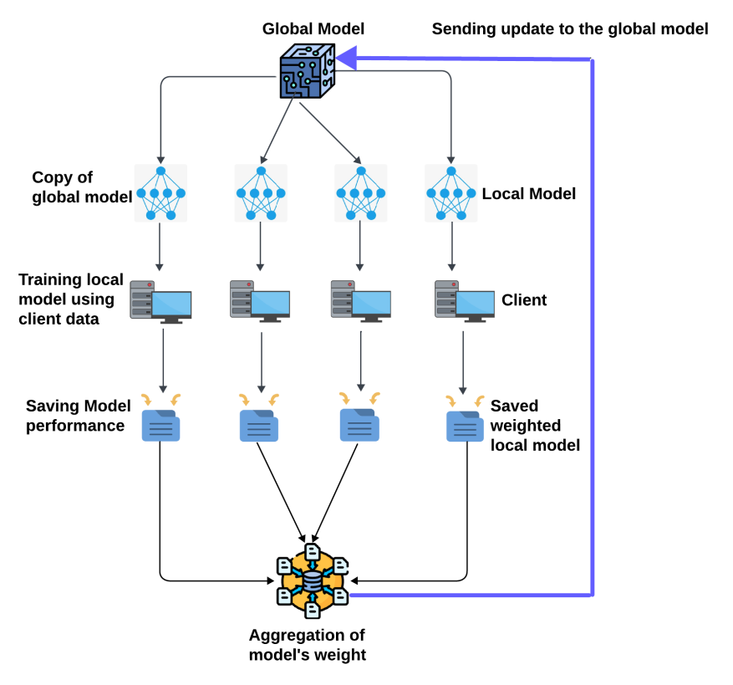

Figure 3. Architecture of federated learning (FL) environment.

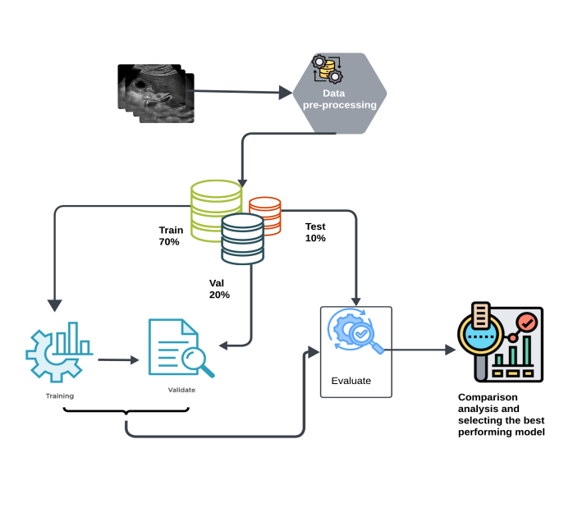
Figure 4. The steps taken to find the most effective model.

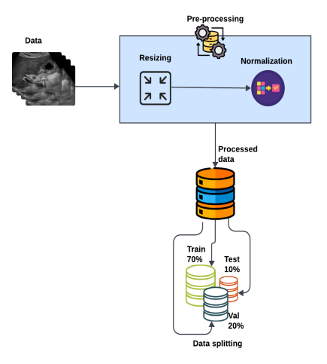
Figure 5. Steps of data pre-processing.
Proposed Model
The two stages of our proposed methodology are outlined in Figs 4, 5, and 6. This approach ensures the model is optimized for real-world applications where data privacy and distributed computing are critical.
The first stage is identifying the most effective DL model for gallbladder classification, which is illustrated in Fig 4. The first step was to find data from the original source and preprocess it. For pre-processing the data we resize and normalize the pixel values of Cholecystography images and reduce the resolution to 64×64. Then we split the image dataset into 7:2:1 ratios where 70% randomly picked images for train models, 20% for validation and 10% for testing the models for evaluating the process. The data pre-processing part is shown in Fig 5. Via this pre-process dataset, we have trained our DL models, evaluated the performance of the models VGG16, Resnet50 and Vision Transformer (Vit).
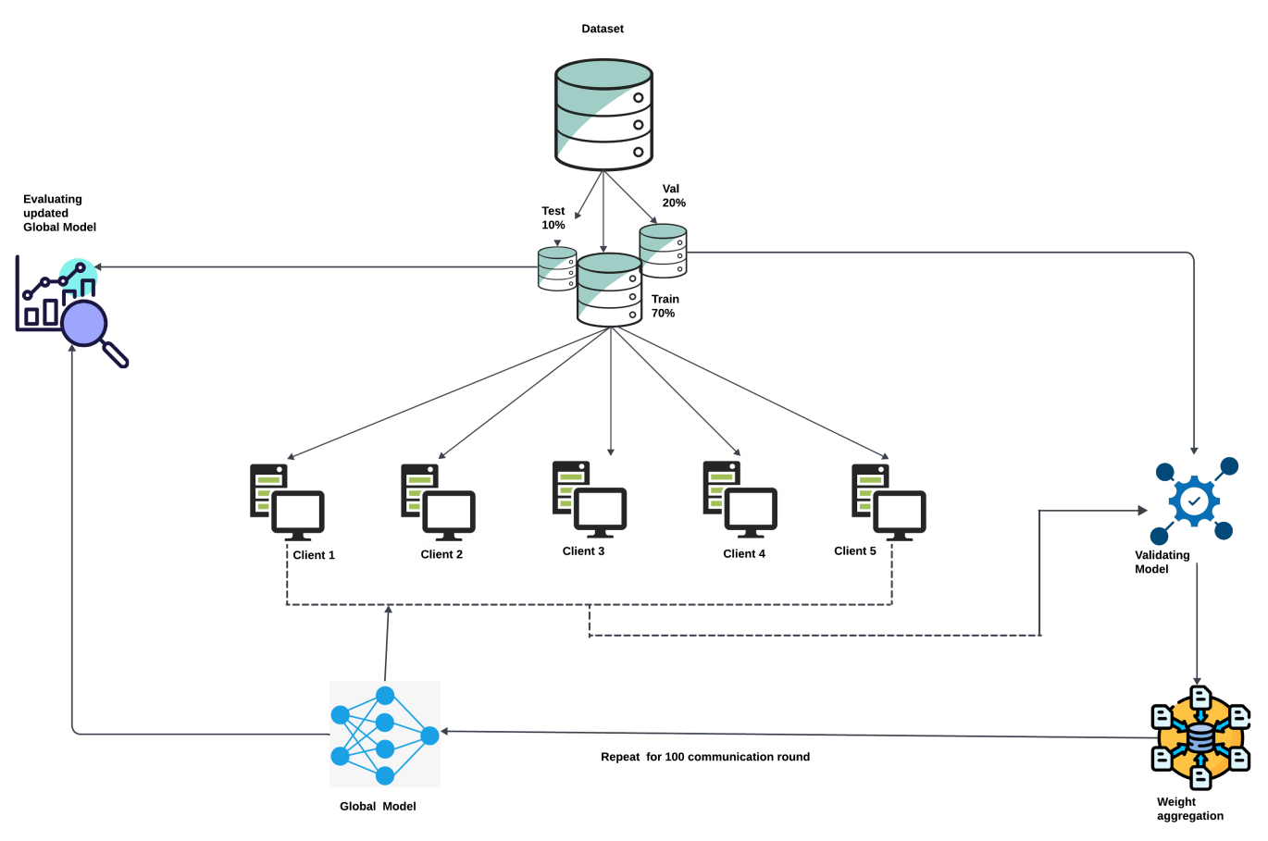
Figure 6. The proposed model for classifying gallbladder under FL environment.

Next, selecting the best-performing DL model we use it for the FL framework. First five local models of the global model the train data is split into five portions. Each of our five clients has given their own unique training set and local model. The clients trained every local model using the given data then the trained model was validated by 20% validation data then it. After the training and validation phase, the trained weight of the five local models was averaged and sent to the global model during each communication round. The training phase had a hundred communication rounds, after that, the updated global model was evaluated by 10% test data. Our proposed model is shown in Fig 6.

Model training
Trained the deep learning (DL) models using labeled cholecystography image datasets. The dataset contains nine different classes. We use TensorFlow and Keras libraries and resize the input image in 64×64 pixels.
The uneven dataset is given in Table 1. Utilized class weight to make sure that the underrepresented classes learned effectively during training. The batch size was sixty-four and the total epoch was fifty. Using equation (1) calculate the class weights where,
• N_{T}​: Total number of training images
• N_{TCN}​​: Number of training images in a specific class
• N_{C}: Total number of classes
Weight_{class} = $\frac{N_{T}}{N_{TC ×N_{C}}}$ ​​ (1)

Class | Number of Images | Calculated Weight
Class 1 | 928 | 0.8961
Class 2 | 819 | 1.0153
Class 3 | 802 | 1.0369
Class 4 | 857 | 0.9703
Class 5 | 743 | 1.1192
Class 6 | 714 | 1.1646
Class 7 | 815 | 1.0203
Class 8 | 1,113 | 0.7471
Class 9 | 693 | 1.1999

Table 1. Weighted for the classes of gallbladder dataset.

Model validation
The validation set carries 20% of the original data which was utilized to validate model performance. It is necessary to check the model's progress after each iteration throughout the training. The 20% validation data is unseen for the model which is used to measure the model’s accuracy, if the validation results are consistent with the test results then we can confirm that the results are reliable and unbiased.

Model testing
From the original dataset, 10% of gallbladder data was kept aside for testing the model. To avoid biased results it is necessary to test it on entirely new data after training. This can ensure how well the trained model can identify with the unknown data.

Weight aggregation
Client-server structure is used in our federated learning framework which means, there are five global model copies known as the local models. Each client trained their own local model with their unique dataset. The server then combines the model weights from all clients and sends the updated result to the global model. “Vanilla averaging” is the easiest method for averaging weights but this method could cause problems if any of the clients have errors or are compromised, as it treats all clients similarly.

W_{avg} $=\sum_{n=1}^{k}{}\frac{i}{k}W_{n}$ (2)

Here, k = is the number of clients.
W_{n =} Weights from the n^{th} client.
W_{avg} = Average weights

To solve this “weight averaging” method was used which considers each client’s model accuracy. The equation is,

W_{avg} = $\sum_{n=1}^{k}{}\frac{ϕ_{n}(x)}{\sum_{n=1}^{k}{}ϕ_{n}(x)}×w_{n}$ (3)

Here, each client’s local model accuracy is symbolized as $ϕ_{n}(x)$ where n is the client number. All clients’ accuracy is summed up with $\sum_{n=1}^{k}{}ϕ_{n}(x)$. It divides model accuracy $ϕ_{n}(x)$ with aggregated accuracy scores to scale the individual model weight. Then for model weight aggregation, scaled weights were used.

Experimental result analysis
To identify the best model for classifying gallbladder we evaluate the performance of the models. We select the best model for the FL framework based on metrics like precision, recall, F1-score, confusion matrix, accuracy and loss. For this the equations are,

Accuracy = $\frac{TP+TN}{TP+TN+FP+FN}$ (4)

Precision = $\frac{TP}{TP+FP}$ (5)

Recall = $\frac{TP}{TP+FN}$ (6)

$f1- score= \frac{2 ×TP}{2×TN+FP+FN}$ (7)

Specificity = $\frac{TN}{TN+FP}$ (8)

To achieve high accuracy and reduce loss was our core goal. We trained each model for fifty epochs utilizing the Adam optimizer keeping a learning rate 0.00001. We selected the best-performing DL model as the global model for the FL framework based on the evaluation metrics. The selected model was then used in the FL framework for further training.

Training and validation accuracy curves of ResNet50 Training and validation loss curves of ResNet50
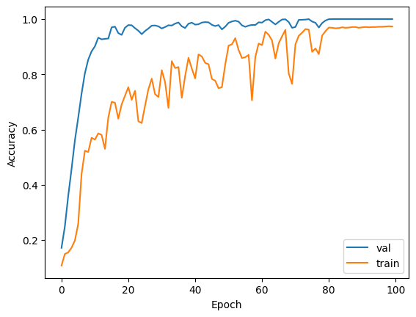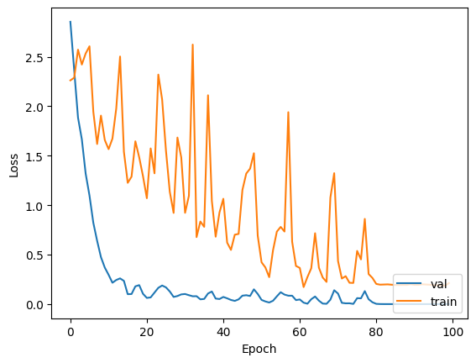
- (b)

Figure 7. ResNet50 (a) accuracy (b) loss curve.

Training and validation accuracy curve for VGG16 Training and validation loss curve for VGG16
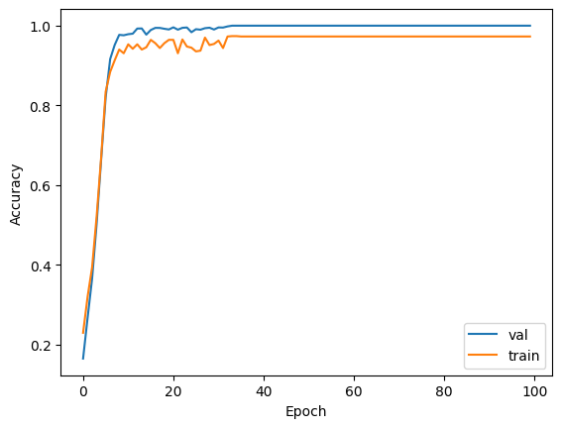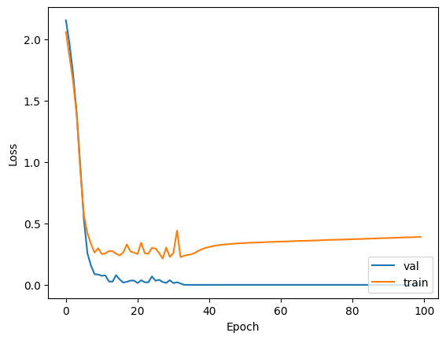
- (b)
Figure 8.VGG16 (a) accuracy (b) loss curve.

Training and validation accuracy curve for vision transformer Training and validation loss curve for vision transformer

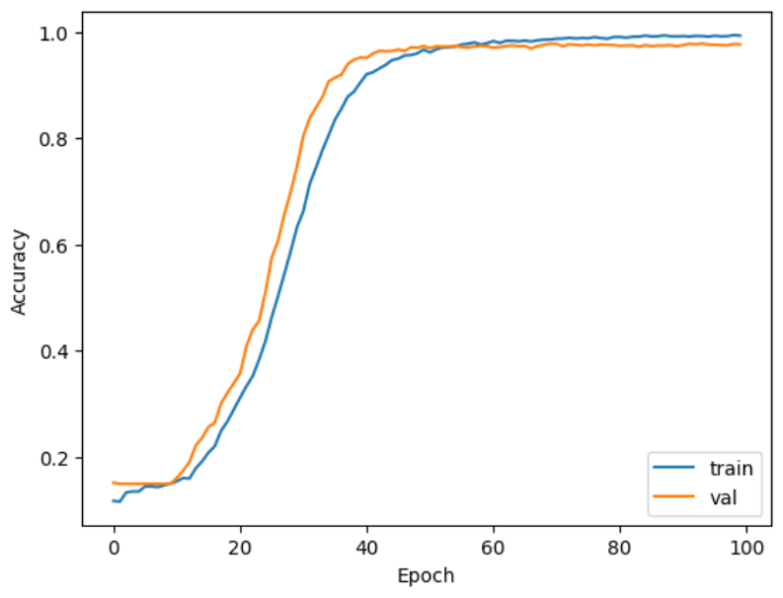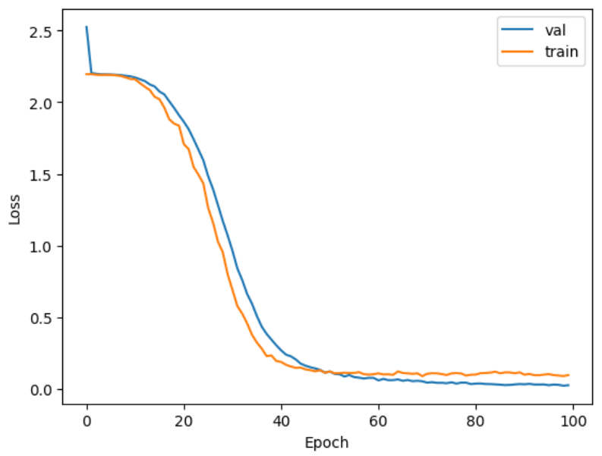
- (b)
Figure 9. Vision transformer (a) accuracy (b) loss curve.

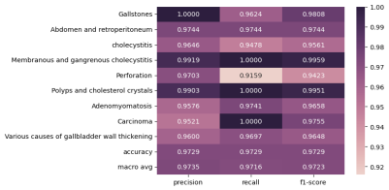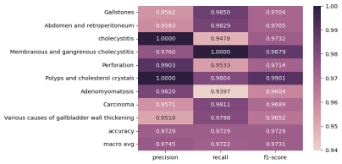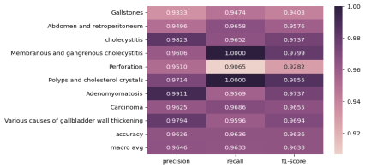
- (b) (c)
Figure 10. Classification report of (a) ResNet50 (b) VGG16 (c) and vision transformer.

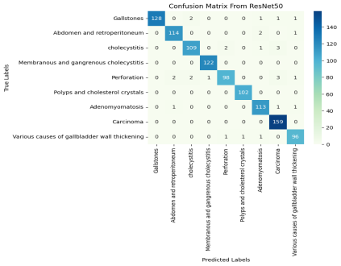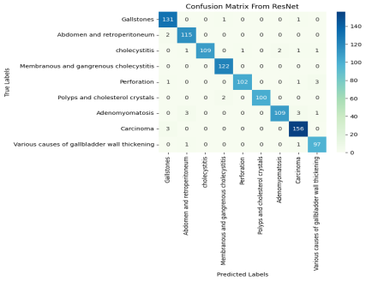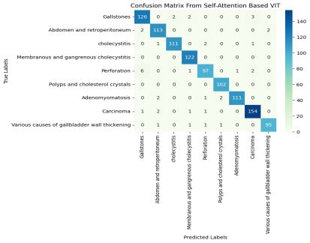

(a) (b) (c)
Figure 11. Confusion matrices of (a) ResNet50 (b) VGG16 (c) vision transformer.

Performance evaluations of DL models
To find the best-fitted deep learning model for the FL framework we trained ResNet50, VGG16 and Vision transformer (Vit). Individually trained these three models for a hundred epochs each. The results are shown in Figs 7, 8, 9, 10 and 11. Tanning and validation loss and accuracy curves show that both models VGG16 and Vit got their stability at around 50 epochs where ResNet50 shows irregular spikes which means there is some slight over-fitting or learning instability. Shown in Figs. 7, 8 and 9.
According to the classification results of these three models shown in Fig. 10 ResNet50 and VGG16 show the highest accuracy 97% but VGG16 has slight dips for some classes. For ResNet50 and Vit Perforation class has the lowest result and for VGG16 Adenomyomatosis class has the lowest result. But ViT accuracy is 96% which is lower than the other two models. From the classification results of the models, we can tell that VGG16 and ResNet50 have the highest scores for precision, recall and fi-score. From Fig 11. ResNet50 and Vit scores are low for the class Perforation and Various causes of gallbladder wall thickening but VGG16 performs highest here also. The overall accuracy of the VGG16 and ResNet50 models are the same as shown in Figure 12. VGG16 has the lowest number of trainable parameters which makes it best for the FL framework. As FL requires a lightweight model for less computational power and energy also reduces communicational costs. Thus we choose VGG16 as our best-fitted model for the FL framework.

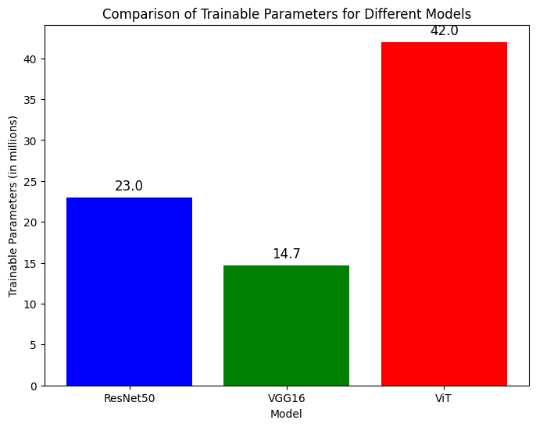
Figure 12. Number of trainable parameters in the models.

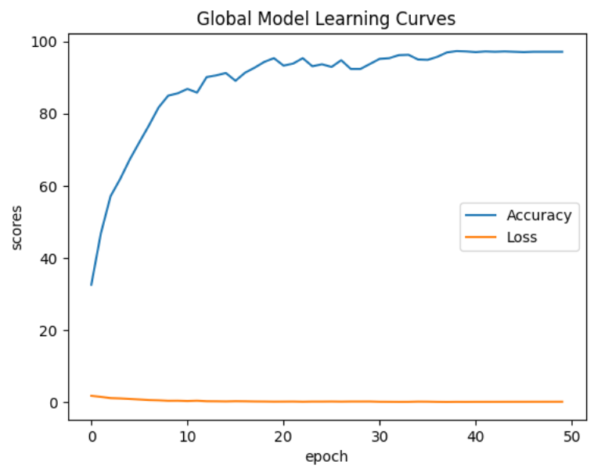
Figure 13. Federated learning model accuracy and loss with weight averaging curve.

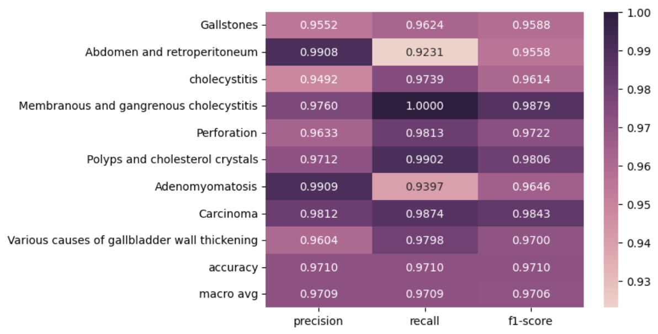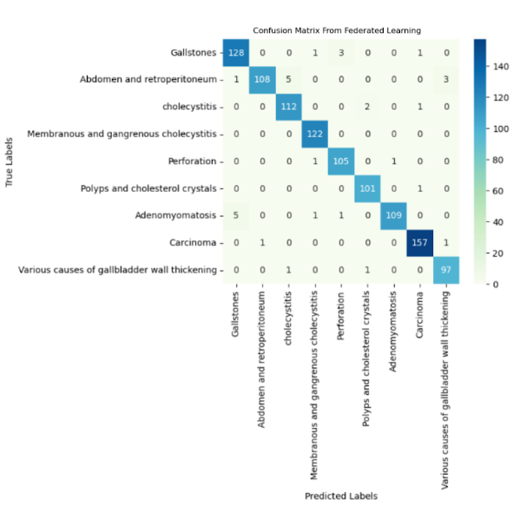
- (b)

Figure 14. Federated learning classification matrix (a) and confusion matrix (b).

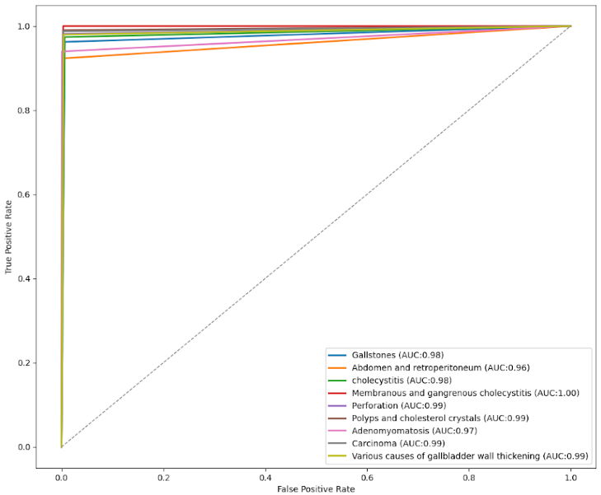
Figure15. ROC graph for FL global model.
Performance under federated learning
We created our FL environment by dividing the data into five clients and kept a test set to analyze the performance of the federated global model. The communication round was 100, and each communication round represents one epoch on each client’s dataset. In Fig 13. The learning curve shows the accuracy and the loss of the model. In the beginning, the accuracy was low around 40% but it increased quickly in the first few epochs. After 20 epochs it smooths and plateaus at a high value almost close to 100%. The loss curve remained low and it was constant throughout the whole training process. We can see most classes have precision, recall, and F1- scores above 0.95 which means the model's performance is excellent shown in Fig 14. Membranous and Gangrenous Cholecystitis gain the perfect recall(1.00) and Abdomen and Retroperitoneum have a little lower recall (0.9231). The model’s overall accuracy is 0.9710 which shows the model is highly accurate. The accuracy achieved by the centrally learned VGG16 model was 0.9729 means the model can classify gallbladder disease accurately even under FL environment. Also, the macro average results precision, recall and F1-score are 0.9709, 0.709 and 0.976 which shows balanced performance in all classes. In the ROC curve in Fig 15. also shows that most of the AUC results are above 0.96 which shows excellent model performance. Thus this research proves the efficiency of FL for gallbladder classification on the Cholecystography image dataset.
Discussion
FL allows privacy-protected model training. In the health field privacy is crucial, the proposed research explores the efficiency of FL in detecting gallbladder disease. In the centralized training we train three different models and evaluate them to find the best-fit model for the FL framework. We identified that the VGG16 model was the best performing model in the centralized part and also light weighted model with fewer parameters which makes it ideal for the FL framework as it cuts network-related issues during the training process. The VGG16 model performs well also in the decentralized process. The result of VGG16 was 97% which matches the centralized VGG16 model result, which indicates that VGG16 performs well in the FL setting as well.
Conclusion
For privacy concerns, limited access to the dataset is a challenge, which makes it difficult to work with medical images and Machine Learning models. Federate learning (FL) helps protect client’s data during model training. This research focused on solving the problem of centralized data collecting for gallbladder images using FL. Different deep learning models VGG19, ResNet50 and vit, were used to train the gallbladder dataset. We split the dataset into a 7:2:1 ratio of 70 % train 20% val and 10% to test the models. VGG16 and RsNet50 models achieved the same accuracy of 97% in the centralized stage but the VGG16 model trainable perimeter is lower than ResNet50 which makes VGG16 ideal for the FL setting thus VGG16 was selected for the FL framework. Then trained the FL framework while protecting the client’s privacy. The FL model achieved the same accuracy as the centralized VGG16 model of 97% with weight averaging while maintaining data privacy. The results show that FL can provide the same performance as traditional deep learning methods in detecting gallbladder disease. This research proves that FL can protect client data while producing high accuracy in detecting gallbladder diseases.

Data availability
Data for this research is available at https://data.mendeley.com/datasets/r6h24d2d3y/2 (Accepted 11 April 2024).
Received: 24 January 2024; Accepted:11 April 2024
Available online: 15 April 2024

References
[1] M. H. Yu, Y. J. Kim, H. S. Park, and S. Il Jung, “Benign gallbladder diseases: Imaging techniques and tips for differentiating with malignant gallbladder diseases,” World J. Gastroenterol., vol. 26, no. 22, pp. 2967–2986, 2020, doi: 10.3748/wjg.v26.i22.2967.
[2] C. B. Duncan and T. S. Riall, “Evidence-Based Current Surgical Practice: Calculous Gallbladder Disease,” J. Gastrointest. Surg., vol. 16, no. 11, pp. 2011–2025, 2012, doi: 10.1007/s11605-012-2024-1.
[3] A. Haleem and I. H. Khan, “Journal Pre-proof,” 2019.
[4] J. Chen, H. Yan, Z. Liu, M. Zhang, H. Xiong, and S. Yu, “When Federated Learning Meets Privacy-Preserving Computation,” ACM Comput. Surv., vol. 56, no. 12, 2024, doi: 10.1145/3679013.
[5] G. Litjens et al., “A survey on deep learning in medical image analysis,” Med. Image Anal., vol. 42, no. 1995, pp. 60–88, 2017, doi: 10.1016/j.media.2017.07.005.
[6] K. Yuan et al., “Risk prediction and analysis of gallbladder polyps with deep neural network,” Comput. Assist. Surg., vol. 29, no. 1, p., 2024, doi: 10.1080/24699322.2024.2331774.
[7] I. Esen, H. Arslan, S. Akturk Esen, M. Gulsen, N. Kultekin, and O. Ozdemir, “Early prediction of gallstone disease with a machine learning-based method from bioimpedance and laboratory data,” Med. (United States), vol. 103, no. 8, p. E37258, 2024, doi: 10.1097/MD.0000000000037258.
[8] A. M. Obaid, A. Turki, H. Bellaaj, M. Ksantini, A. AlTaee, and A. Alaerjan, “Detection of Gallbladder Disease Types Using Deep Learning: An Informative Medical Method,” Diagnostics, vol. 13, no. 10, 2023, doi: 10.3390/diagnostics13101744.
[9] P. Gupta et al., “Deep-learning enabled ultrasound based detection of gallbladder cancer in northern India: a prospective diagnostic study,” Lancet Reg. Heal. - Southeast Asia, vol. 24, p. 100279, 2024, doi: 10.1016/j.lansea.2023.100279.
[10] Y. Zhou et al., “Multi-clinical index classifier combined with AI algorithm model to predict the prognosis of gallbladder cancer,” Front. Oncol., vol. 13, no. May, pp. 1–10, 2023, doi: 10.3389/fonc.2023.1171837.
[11] S. Alazwari, J. Alsamri, M. Alamgeer, S. S. Alotaibi, M. Obayya, and A. S. Salama, “Automated gall bladder cancer detection using artificial gorilla troops optimizer with transfer learning on ultrasound images,” Sci. Rep., vol. 14, no. 1, p. 21845, 2024, doi: 10.1038/s41598-024-72880-4.
[12] T. Kim, Y. H. Choi, J. H. Choi, S. H. Lee, S. Lee, and I. S. Lee, “Gallbladder polyp classification in ultrasound images using an ensemble convolutional neural network model,” J. Clin. Med., vol. 10, no. 16, 2021, doi: 10.3390/jcm10163585.
[13] S. Basu, M. Gupta, P. Rana, P. Gupta, and C. Arora, “Surpassing the Human Accuracy: Detecting Gallbladder Cancer from USG Images with Curriculum Learning,” Proc. IEEE Comput. Soc. Conf. Comput. Vis. Pattern Recognit., vol. 2022-June, pp. 20854–20864, 2022, doi: 10.1109/CVPR52688.2022.02022.
[14] Q. Li, D. Song, and U. C. Berkeley, “Model-Contrastive Federated Learning,” pp. 10713–10722.
[15] L. Li, N. Xie, and S. Yuan, “A Federated Learning Framework for Breast Cancer Histopathological Image Classification,” Electron., vol. 11, no. 22, pp. 1–14, 2022, doi: 10.3390/electronics11223767.
[16] A. Turki, A. M. Obaid, H. Bellaaj, M. Ksantini, and A. AlTaee, “UIdataGB: Multi-Class ultrasound images dataset for gallbladder disease detection,” Data Br., vol. 54, 2024, doi: 10.1016/j.dib.2024.110426.
[17] J. V. Dillon et al., “TensorFlow Distributions,” 2017, [Online]. Available: http://arxiv.org/abs/1711.10604
[18] B. T. Chicho and A. B. Sallow, “A Comprehensive Survey of Deep Learning Models Based on Keras Framework,” J. Soft Comput. Data Min., vol. 2, no. 2, pp. 49–62, 2021, doi: 10.30880/jscdm.2021.02.02.005.
[19] J. Wen, Z. Zhang, Y. Lan, Z. Cui, J. Cai, and W. Zhang, “A survey on federated learning: challenges and applications,” Int. J. Mach. Learn. Cybern., vol. 14, no. 2, pp. 513–535, 2023, doi: 10.1007/s13042-022-01647-y.
[20] J. Xu, B. S. Glicksberg, C. Su, P. Walker, J. Bian, and F. Wang, “Federated Learning for Healthcare Informatics,” J. Healthc. Informatics Res., vol. 5, no. 1, pp. 1–19, 2021, doi: 10.1007/s41666-020-00082-4.
[21] W. Zhang et al., “Dynamic-Fusion-Based Federated Learning for COVID-19 Detection,” IEEE Internet Things J., vol. 8, no. 21, pp. 15884–15891, 2021, doi: 10.1109/JIOT.2021.3056185.
[22] S. M. Dipto et al., “An analysis of decipherable red blood cell abnormality detection under federated environment leveraging XAI incorporated deep learning,” Sci. Rep., vol. 14, no. 1, p. 25664, 2024, doi: 10.1038/s41598-024-76359-0.

